What is Machine Learning?
This is type of learning where machine tries to learn the data pattern using the different type of algorithms.

What are types of Machine Learning?
- Supervised Machine Learning
- Unsupervised Machine Learning
- Reinforcement Machine Learning

Supervised Machine Learning
This is Type of Learning where Output is already known. For example if you want to predict the type of animal from image, if there is a column where against each animal image you have their types. So, this will be supervised learning.

Different Algorithms under Supervised Machine Learning
Algorithms mainly falls under two categories:
- Classification
- Regression

Let’s go through each Algorithms.
- Linear Models
  - Linear Regression (Regression)
    - Ridge Regression (L2 - Regularized version)
    - Lasso Regression (L1 - Regularized version)
  - Logistic Regression (Classification)
  - Elastic Net (Both)
- Tree based Algorithms (All for Classification and Regression)
  - Decision Tree
  - Random Forest
  - Gradient Boosting
  - XGBoost (Extreme Gradient Boosting)
  - LightGBM (Light Gradient Boosting)
  - CatBoost (Categorical Boosting)
- Support Vector Machines
  - Support Vector Machine (Classification)
  - Support Vector Regression (Regression)
- Instance Based Learning
  - K-Nearest Neighbors
- Probabilistic Models (Classification)
  - Naïve Bayes
  - Gaussian Naïve Bayes
  - Multinomial Naïve Bayes
- Neural Networks (All for Classification and Regression)
  - Artificial Neural Network (ANN)
  - Deep Neural Network (DNN)
  - Convolutional Neural Network (CNN)
  - Recurrent Neural Network (RNN)

Linear Regression
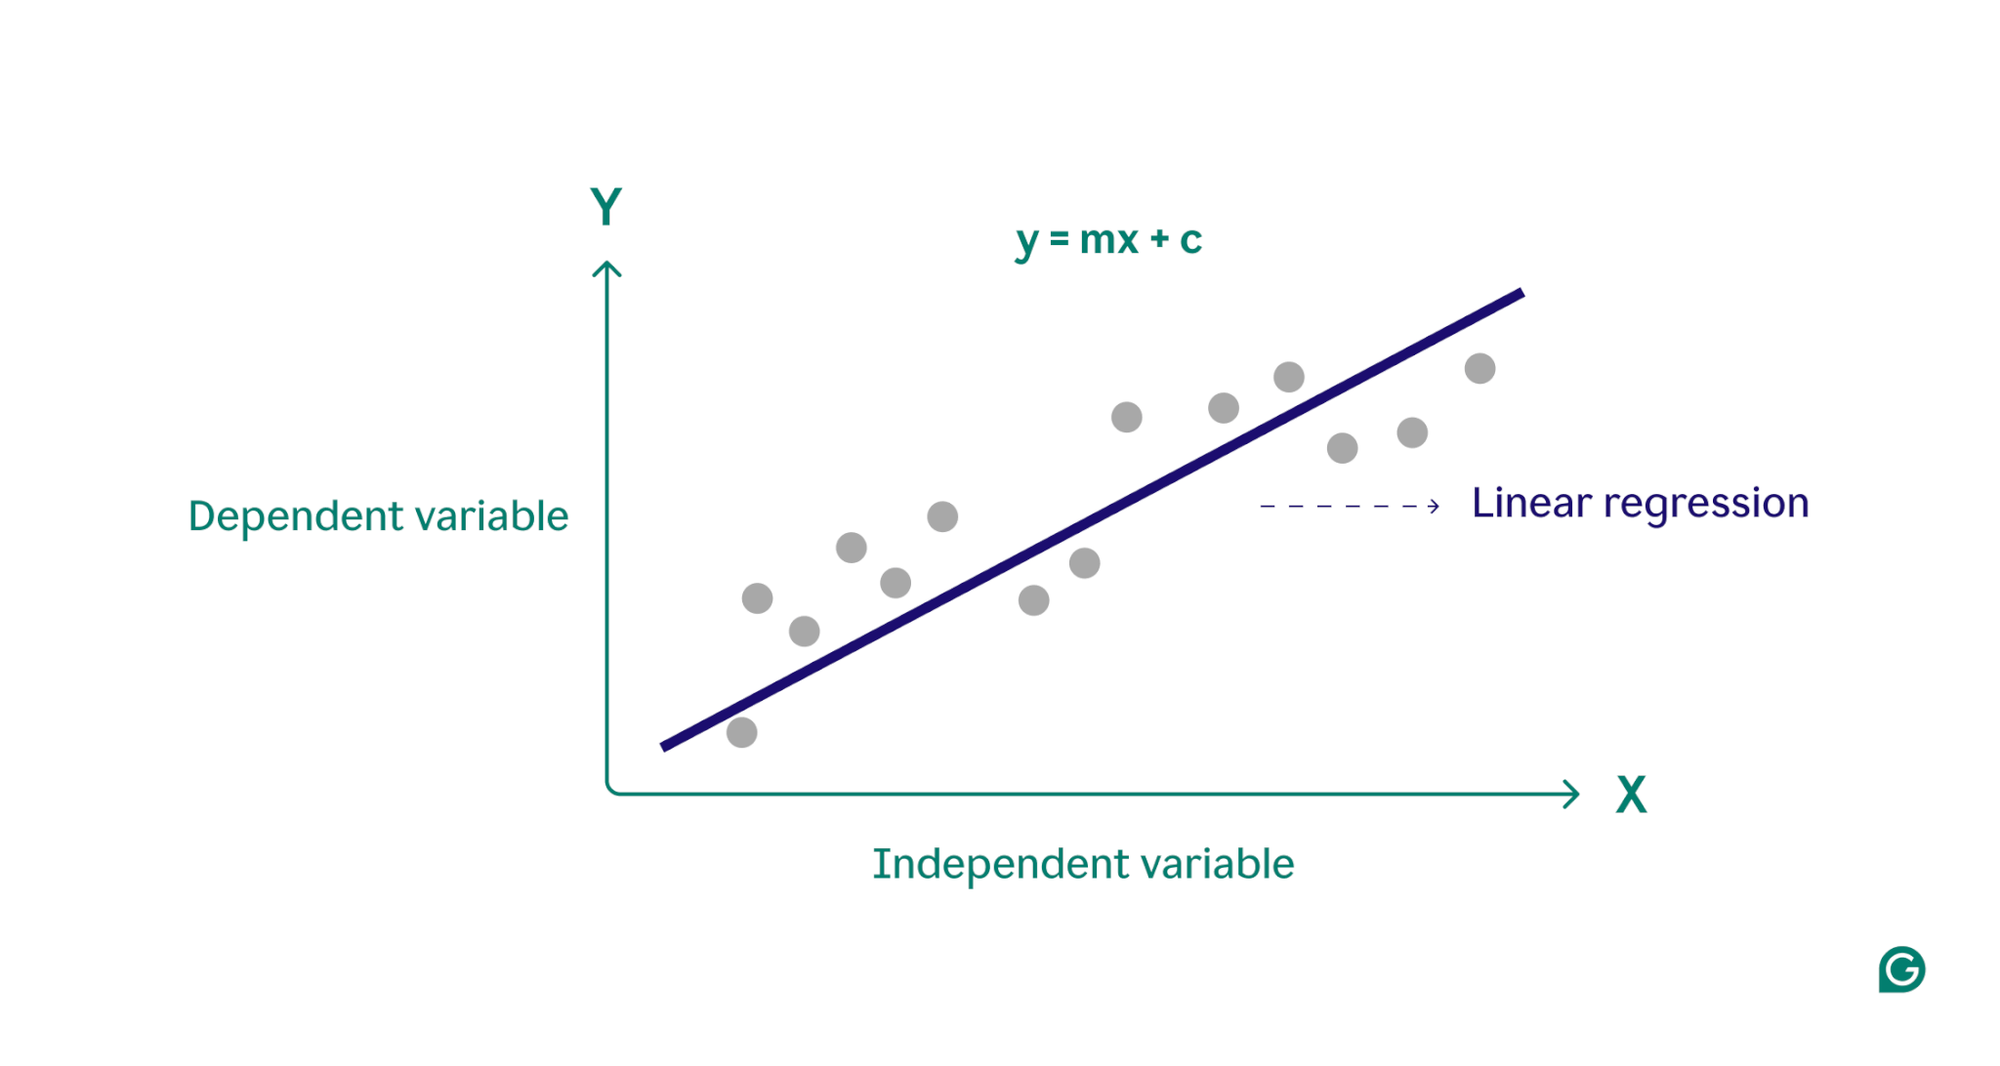

- The term regression is used when you try to find the relationship between variables. (e.g., the relationship between rainfall and soil erosion).
- In Machine Learning and in statistical modelling, that relationship is used to predict the outcome of events.
- Regression models describe the relationship between variables by fitting a line to the observed data.
- Regression allows you to estimate how a dependent variable changes as the independent variable(s) change.
- The simplest possible linear regression model on the web is just the equation of a straight line:

- 𝑦 = 𝑎 + 𝑏𝑥

Where:
  - x = input (independent variable)
  - y = predicted output (dependent variable)
  - b = slope (how much y changes when x changes)
  - a = intercept (value of y when x = 0)

Logistic Regression
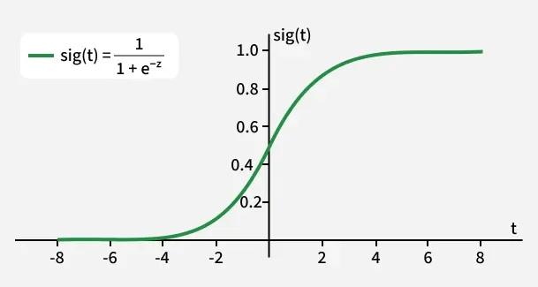
- It is used for binary classification where the output can be one of two possible categories such as Yes/No, True/False or 0/1.
- S-shaped curve → the sigmoid function
- Output is always between 0 and 1
- That value represents a probability
- The sigmoid function is a important part of logistic regression which is used to convert the raw output of the model into a probability value between 0 and 1.

In each Algorithm explanation, Include below
- Import method inside python

